Correlation vs Covariance

Covariance and correlation are two mathematical concepts which are commonly used in statistics. Covariance is used to determine how much two random variables vary together, whereas Correlation, which determines how one variables moves/changes in relation with the other variable. Correlation gives us the idea about the degree of the relationship of the two variables

As Covariance says something on same lines as correlation, correlation takes a step further than covariance and also tells us about the strength of the relationship.

Both can be positive or negative. Covariance is positive if one increases other also increases and negative if one increases other decreases.
Covariance is calculated as
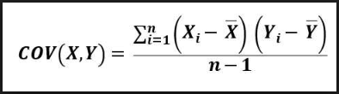

Xᵢ= Observation point of variable X
x̅= Mean of all observations(X)
Yᵢ= Observation point of variable Y
ȳ = Mean of all observations(Y)
n= Number of observations

For example: The following is the dataset .

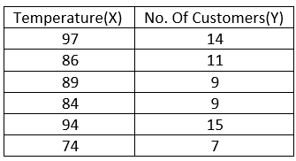
First find means of both the variables, subtract each of the item with its respective mean and multiply it together as follows
Mean of X, x̅ = (97+86+89+84+94+74)/6 = 524/6= 87.333
Mean of Y, Ȳ = (14+11+9+9+15+7)/6 = 65/6= 10.833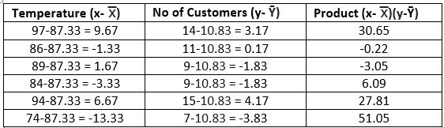
COV(x, y) = 112.33/(6–1) = 112.33/5 = 22.46
The covariance between the temperature and customers is 22.46. Since the covariance is positive, temperature and number of customers have a positive relationship. As temperature rises, so does the number of customers.
But here there is no information about how strong the relationship is, and that’s where correlation comes into the picture.Correlation coefficient is the term used to refer the result of any correlation measurement methods.So here, the sample Correlation coefficient is calculated as
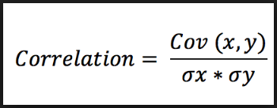
COV(x, y) = covariance of the variables x and y
σx = sample standard deviation of variable x
σy = sample standard deviation of variable y
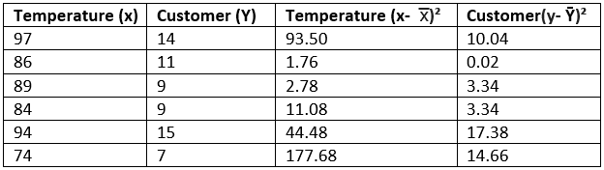
COV(x, y) = 22.46
σx = 331.28/5=66.25= 8.13
σy = 48.78/5=9.75=3.1
correlation = 22.46/(8.13x 3.1)= 22.46/25.20 =0.8
0.8 shows that strength of the correlation between temperature and number of customers is very strong.

1. Pearson Correlation Coefficient
It captures the strength and direction of the linear association between two continuous variables. It tries to draw the line of best fit through the data points of two variables. Pearson correlation coefficient indicates how far these data points are away from the line of best fit. The relationship is linear only when the change in one variable is proportional to the change in another variable.
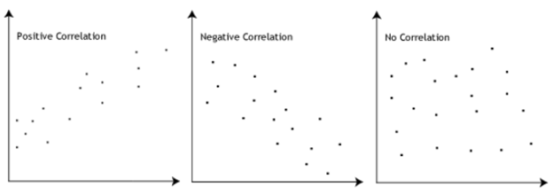
Pearson Correlation Coefficient calculated as
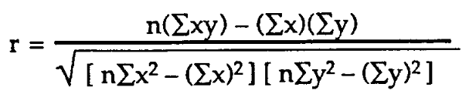
r = Pearson Correlation Coefficient
n = number of observations
∑xy = sum of the products of x and y values
∑x = sum of x values
∑y = sum of y values
∑x2= sum of squared x values
∑y2= sum of squared y values
Spearman’s Correlation Coefficient
It tries to determine the strength and the direction of the monotonic relationship which exists between two ordinal or continuous variables. In a monotonic relationship two variables tend to change together but not with the constant rate. It’s calculated on the ranked values of the variables rather than on the raw data.
Monotonic and non- monotonic relationships are shown below:
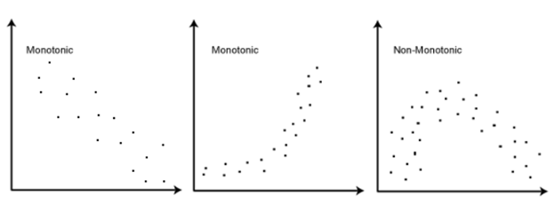
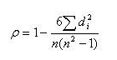
ρ= Spearman rank correlation coefficient
di= the difference between the ranks of corresponding variables
n= number of observations

When to use what?
Pearson correlation describes linear relationships and spearman correlation describes monotonic relationships. A scatter plot would be helpful to visualize the data and understand which correlation coefficient should be used. Other way of doing is to apply both the methods and check which is performing well. For instance if results show spearman correlation coefficient is greater than Pearson coefficient, it means our data has monotonic relationships and not linear.

